Model Question Paper – Cloud Data Engineer - Jain University
Name: Dharnish V HCL ID:HCLTFP2263841
USN: 23BTRCL040 DEPARTMENT: CSE-AIML

SECTION A: ADVANCED SQL || Maximum Marks: 20 Question 1: Database Design and Advanced Queries (8 Marks)
1.Create a database named EnterpriseDB.
2.Department table created
3.Employees table created

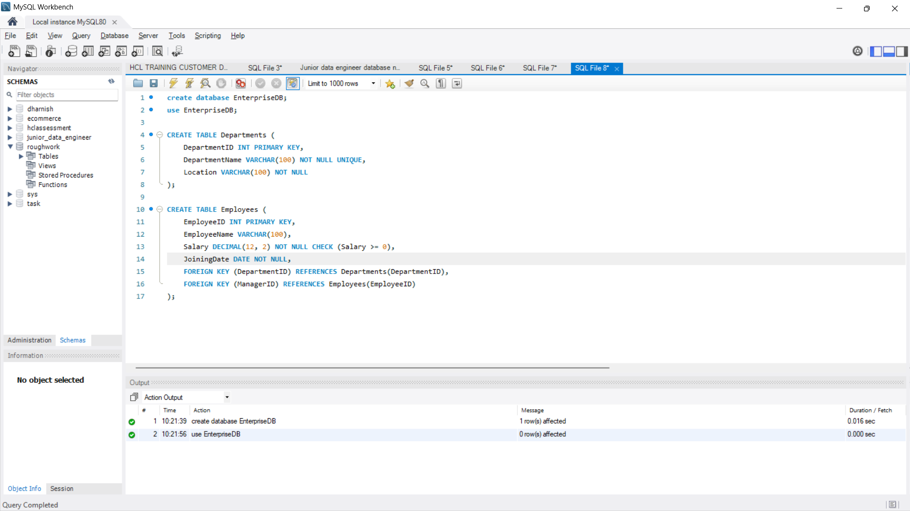
4.Values are inserted in both department table and employees table
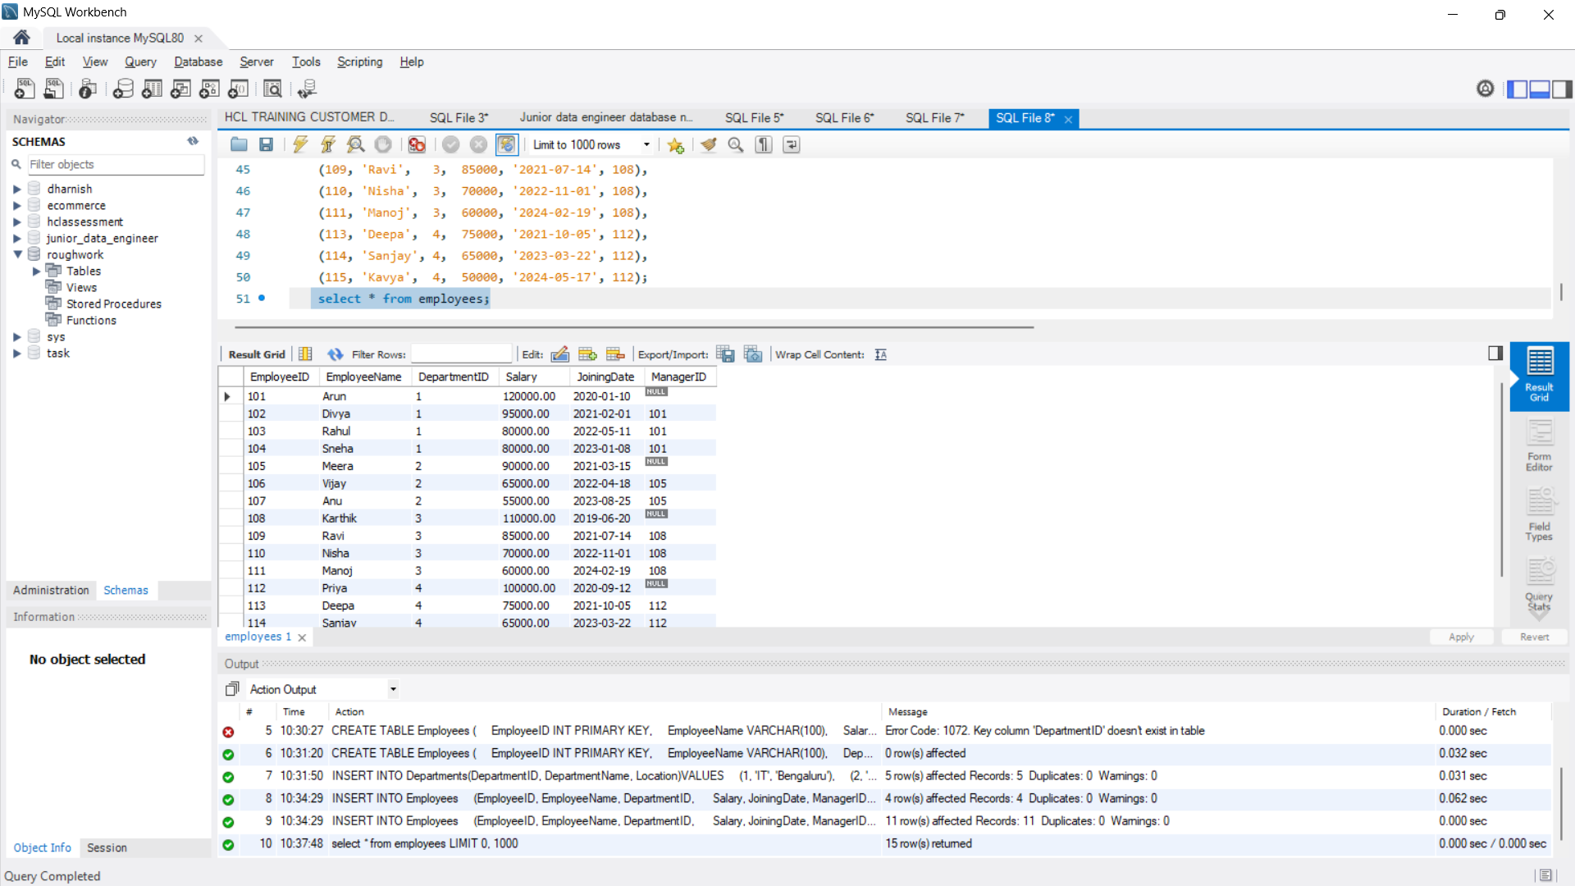
Tasks:
- Display employee names, department names, and manager names using joins. (2 marks)

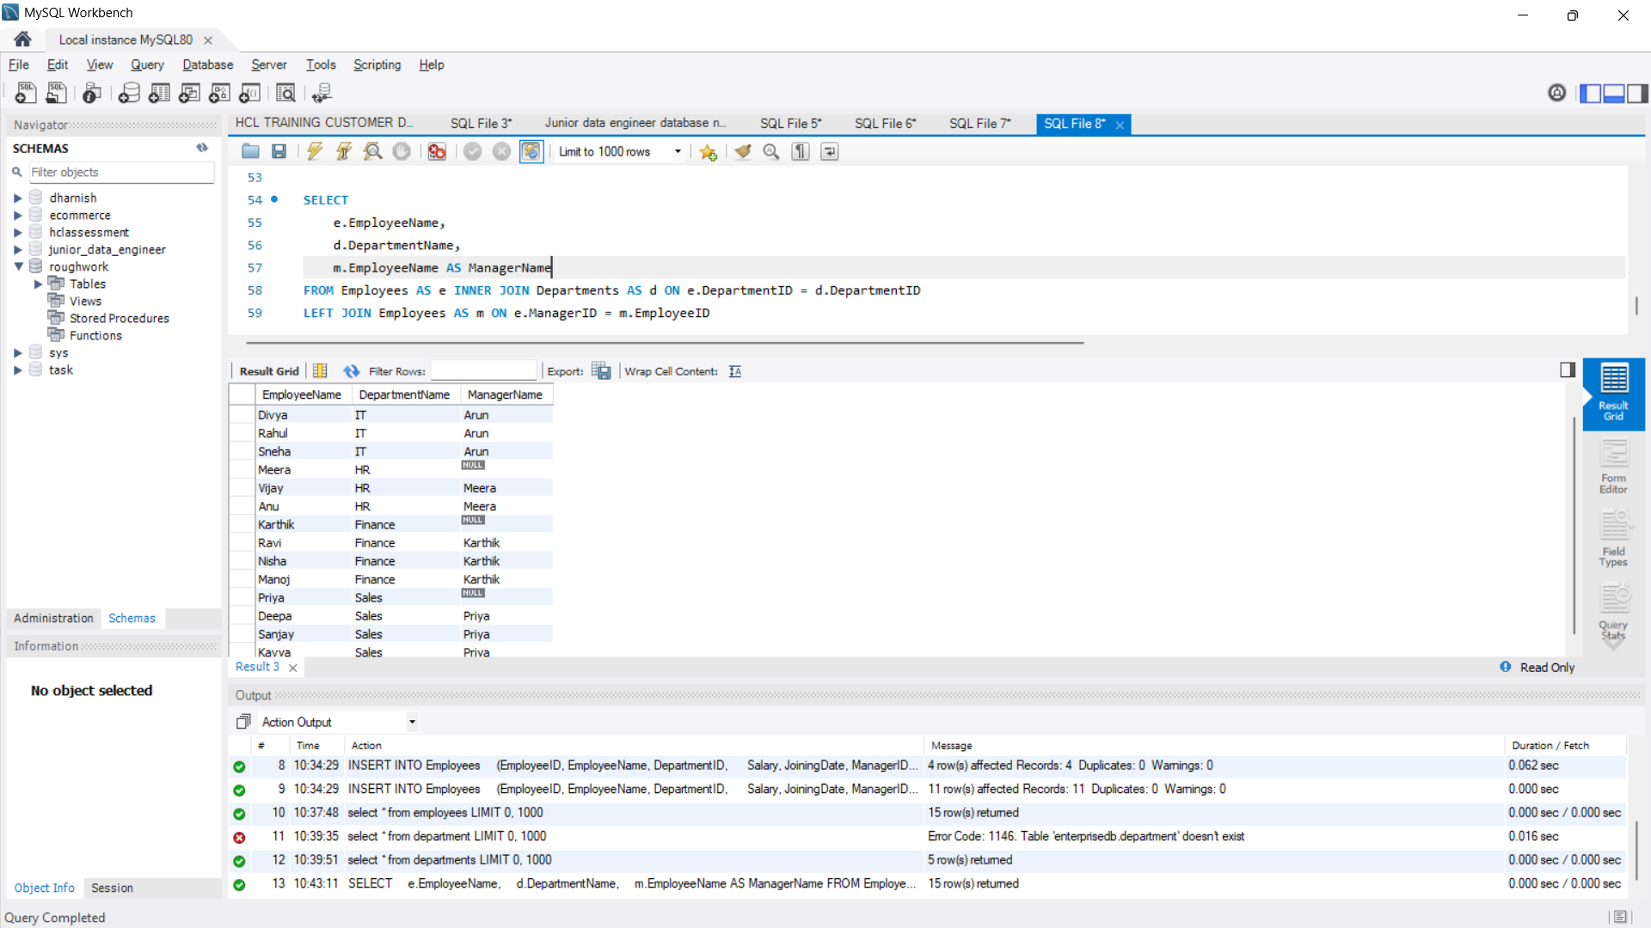
- Find employees earning more than their department's average salary. (2 marks)
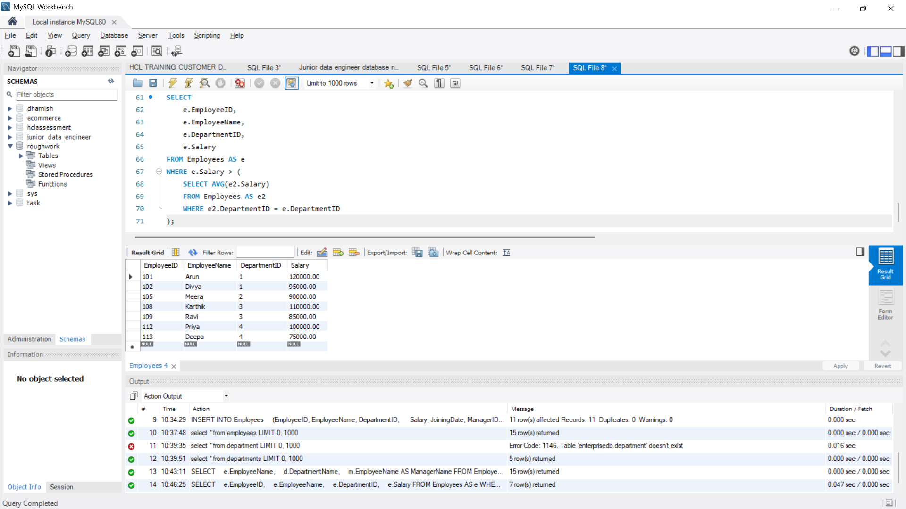
- Find the second-highest distinct salary without using LIMIT, TOP, or FETCH

FIRST. (2 marks)
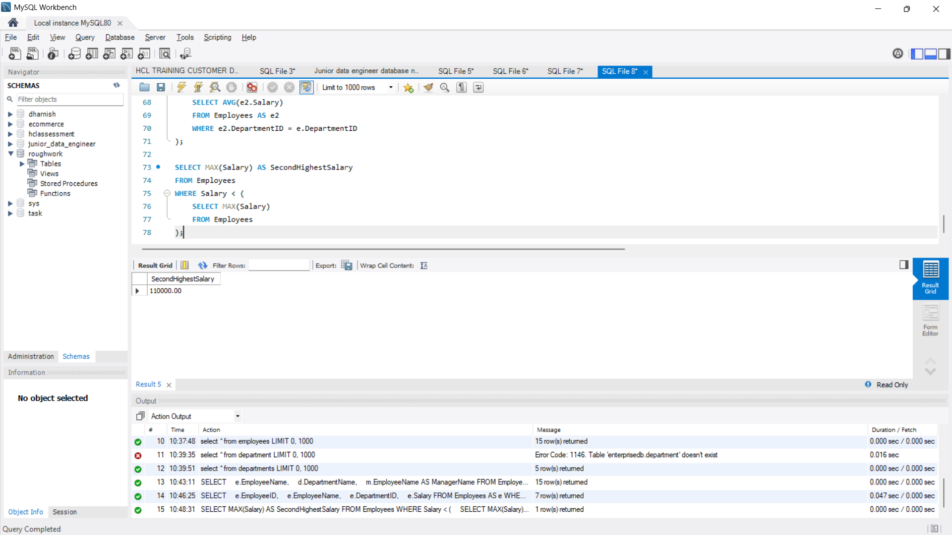
- Rank employees by salary within each department and display the top three employees per department, retaining ties at the cutoff. (2 marks)
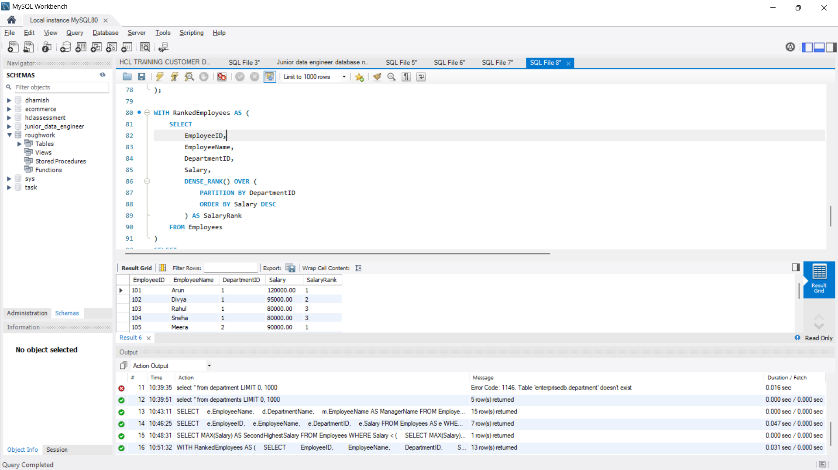

Question 2: Sales Analytics and Query Optimization (6 Marks)
1.Sales table created and values are inserted
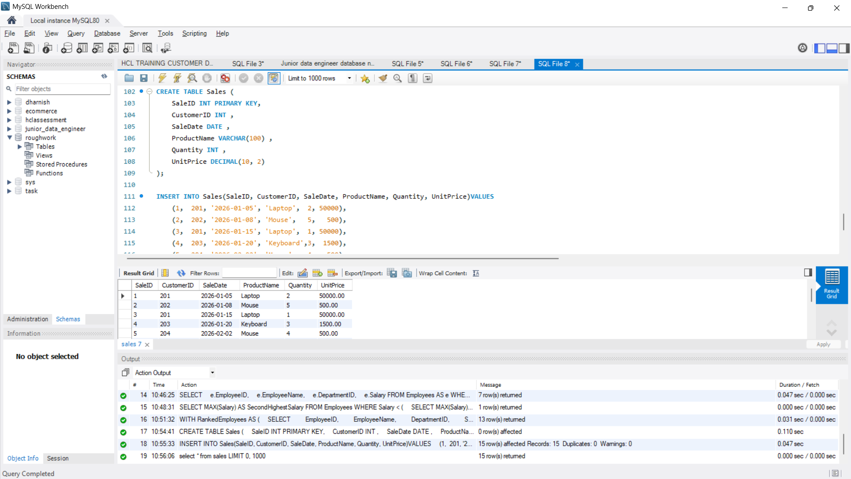
- Calculate total revenue for each product. (2 marks)
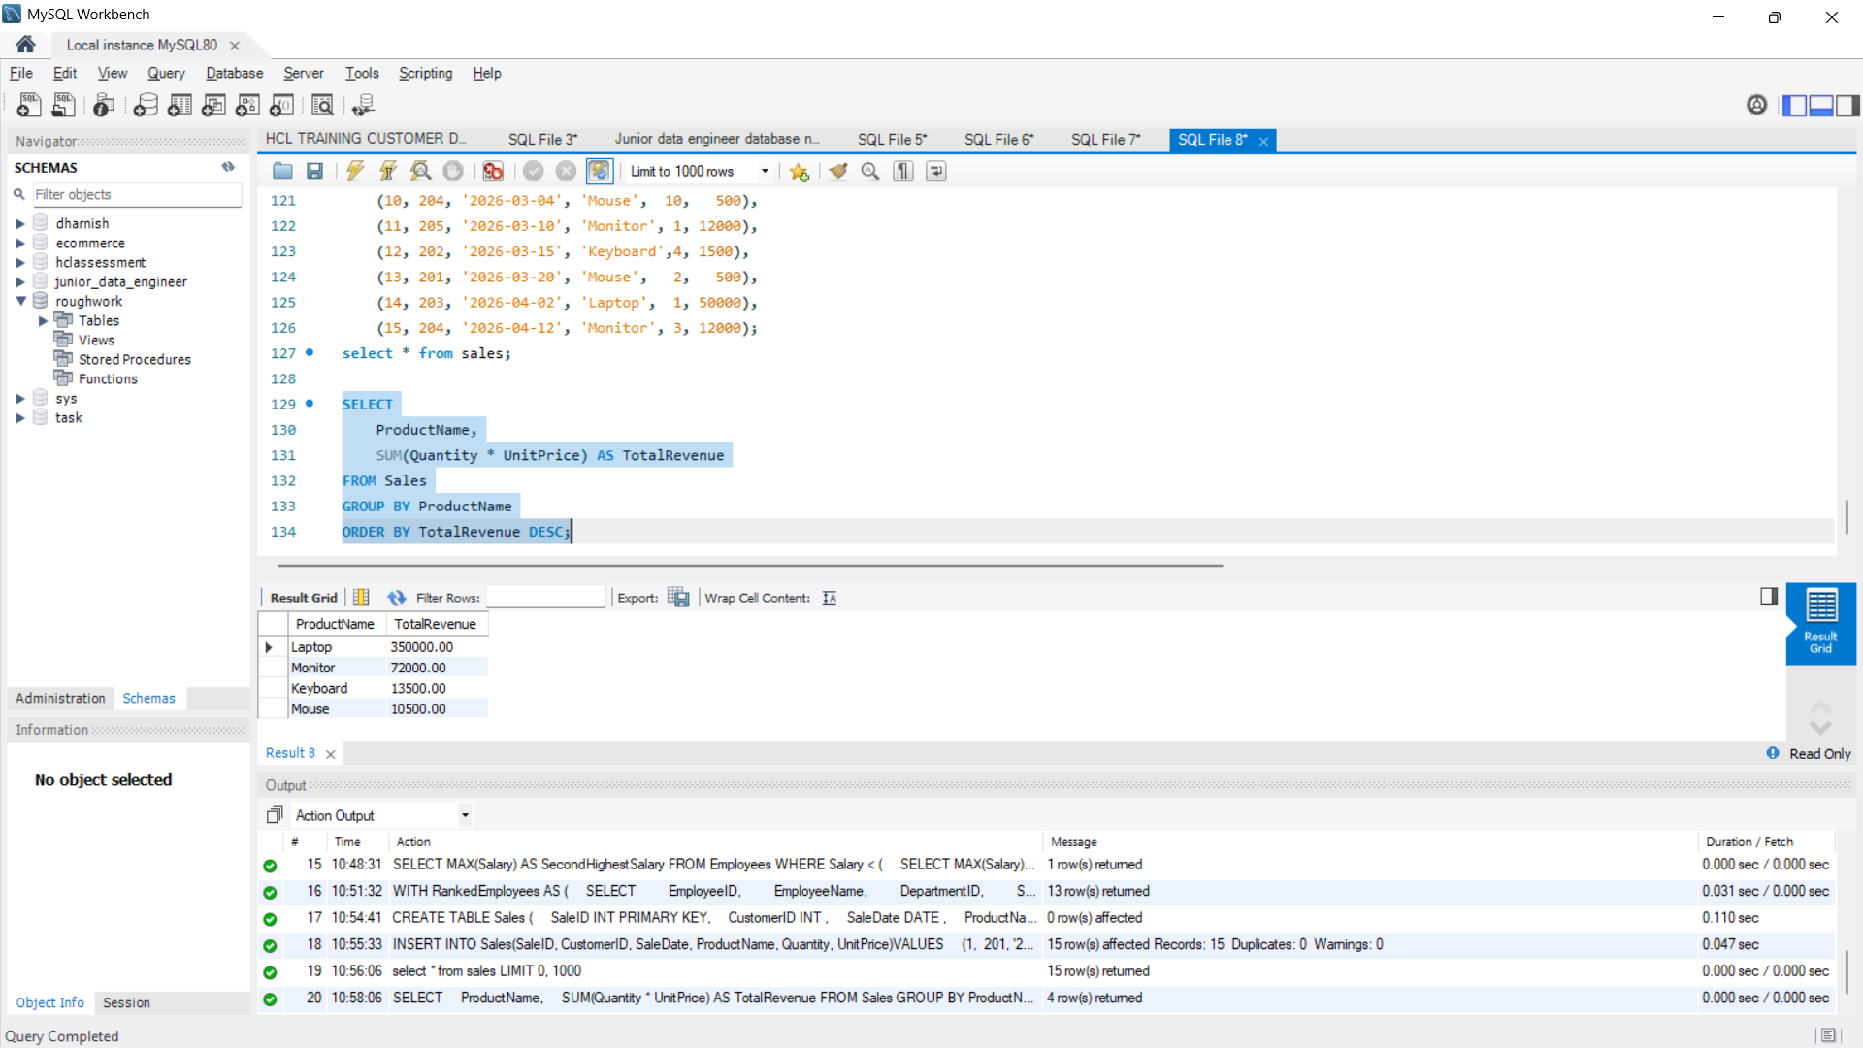
- Calculate monthly revenue and month-over-month revenue change using a window function. (2 marks)
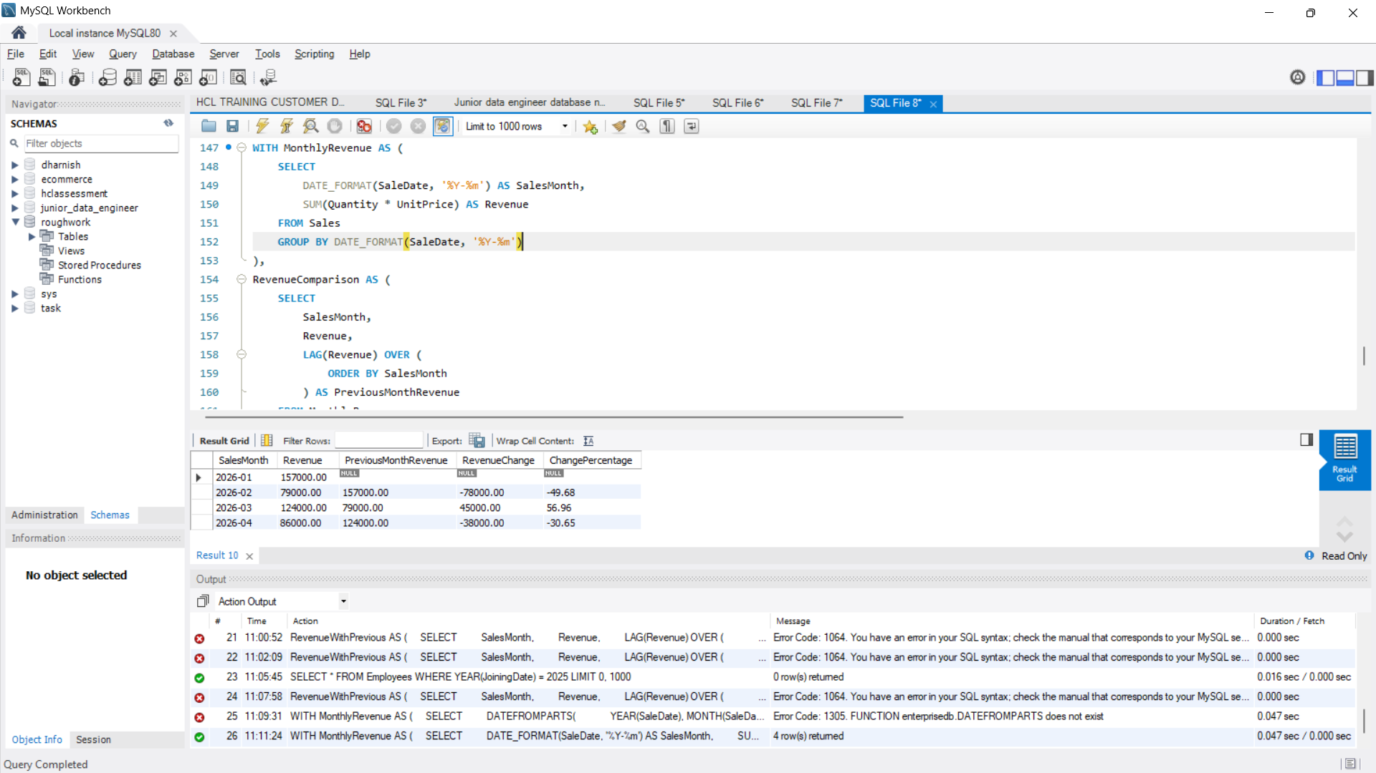
- Rewrite the following query to improve the potential for index usage and explain why your version may perform better. (2 marks)
SELECT *
FROM Employees
WHERE YEAR(JoiningDate) = 2025;
Assume JoiningDate may be indexed.

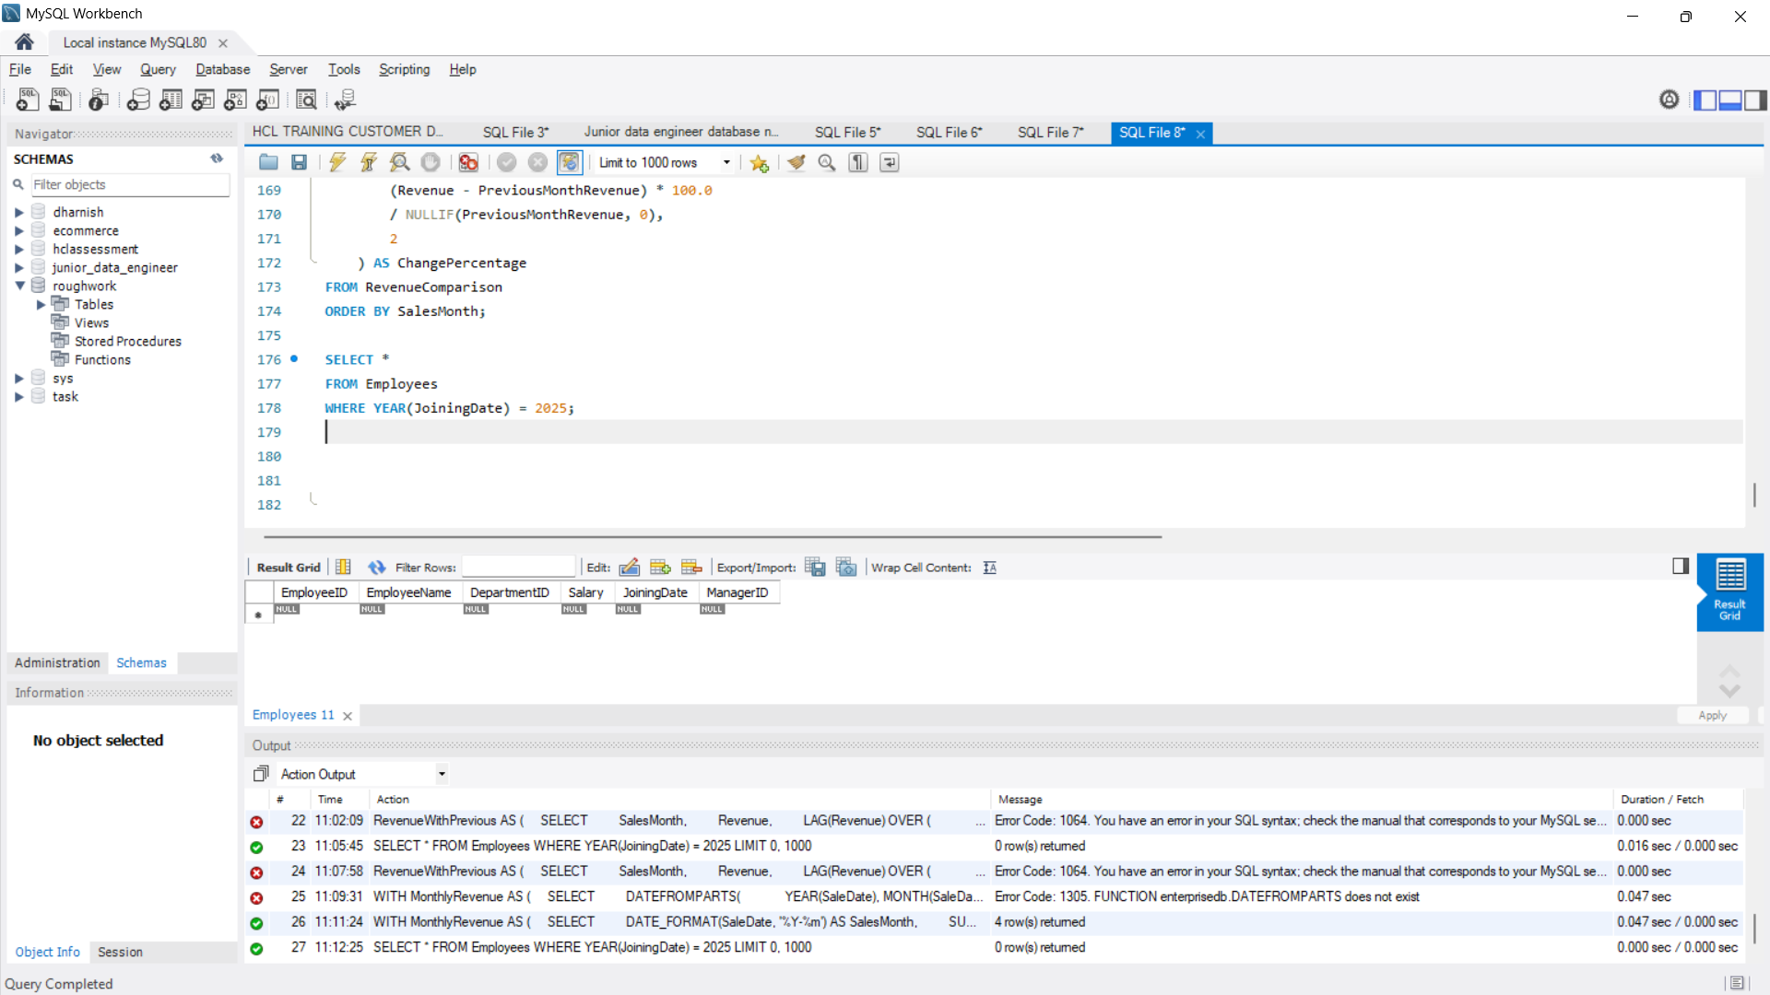

Question 3: SQL Troubleshooting (6 Marks)
A company maintains millions of employee and transaction records. Its reporting queries are running slowly.
Perform the following tasks:
- Explain how an execution plan helps identify expensive operations in a query. (2 marks)
An execution plan shows how the SQL database executes a query and the operations performed to retrieve data.
- Full Table Scan: The database scans all rows, which can be slow for large tables.
- Index Scan/Seek: Uses an index to locate the required rows efficiently.
- Sort and Join Operations: May consume significant CPU and memory.
- Example: If a query scans millions of employee records, an execution plan may reveal that creating a suitable index can improve performance.

- Recommend an appropriate index strategy for queries filtering employees by
DepartmentID and Salary. Explain your reasoning. (2 marks)
- Create a composite index on DepartmentID and Salary.
- SELECT *
FROM Employees
WHERE DepartmentID = 10
AND Salary > 50000;
Reasoning:
- DepartmentID is the first column, so the index efficiently supports filtering by department.
- Salary is the second column, helping filter salary ranges within a department.
- This can reduce the number of rows scanned and improve query performance.

- Write a query to identify duplicate customer email addresses and display only addresses occurring more than once. (2 marks)
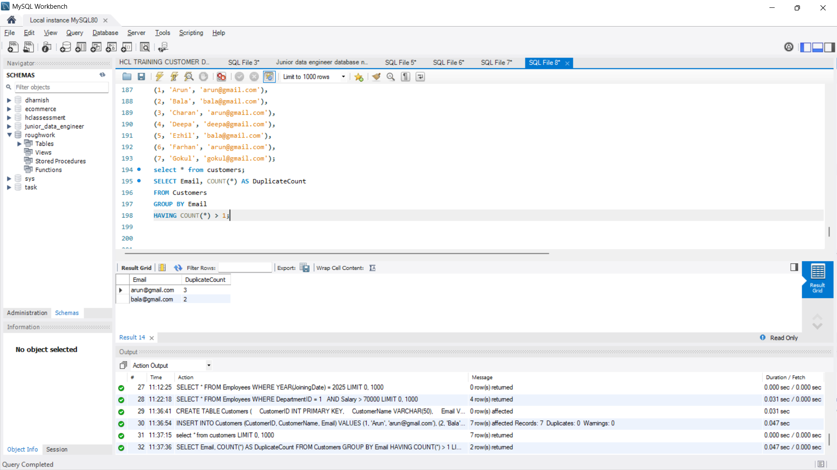
Explanation:
- GROUP BY Email groups records with the same email address.
- COUNT(*) counts the occurrences of each email.
- HAVING COUNT(*) > 1 displays only email addresses that occur more than once.

SECTION B: LINUX || Maximum Marks: 15

Question 4: Log Analysis (5 Marks)
Assume /var/log/application.log contains millions of log entries in the following format:
2026-10-28 10:15:23 ERROR payment-service Transaction failed
- Find all lines containing ERROR. (1 mark)
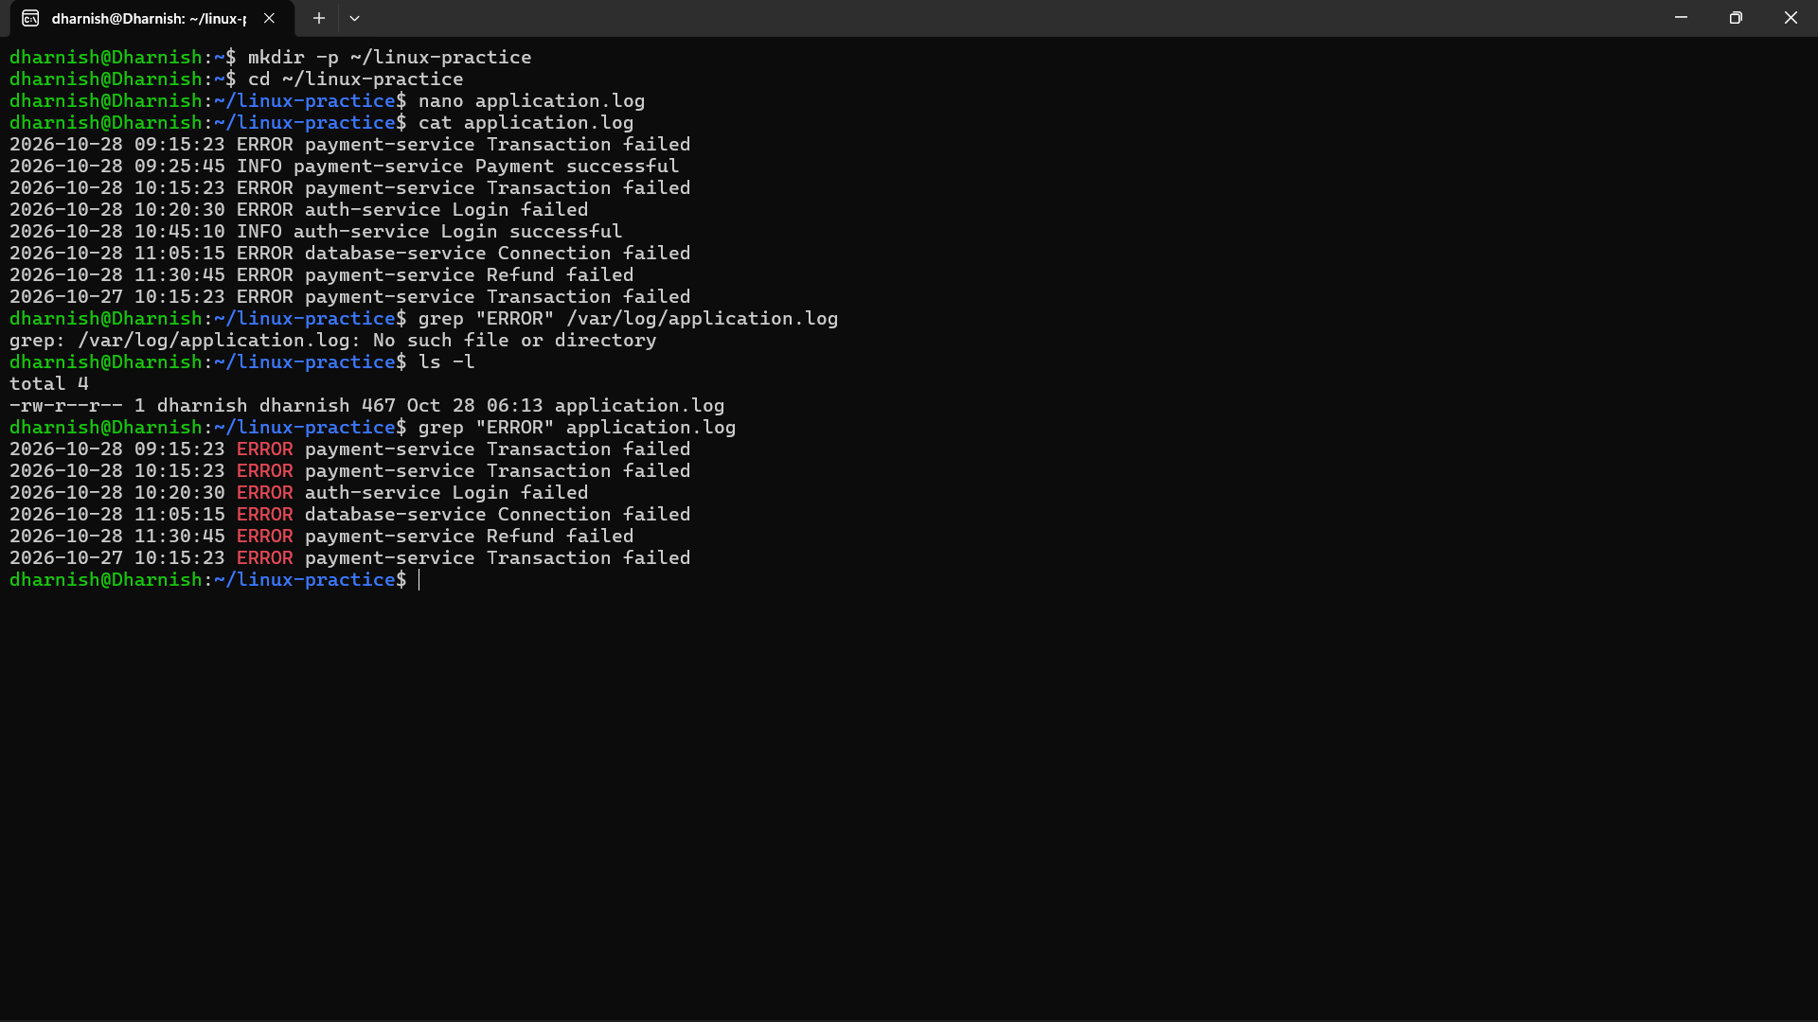

Explanation: grep searches for lines containing the word ERROR and displays them.
- Display the 20 most recent error entries in the file. (1 mark)
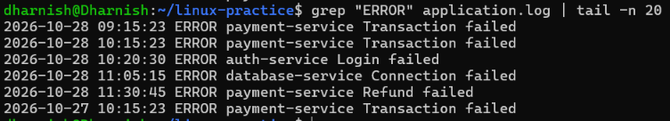
- Count the total number of error entries. (1 mark)
- Extract error entries for a specified date into a separate file. (1 mark)
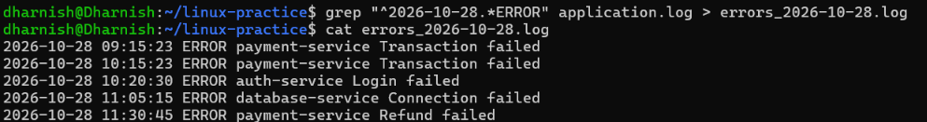
- Explain how you would calculate the number of errors occurring in each hour. (1 mark)

Question 5: Permissions and System Troubleshooting (5 Marks)
A Linux server hosts an application that processes confidential financial reports.
Perform the following tasks:
- Create a group named finance and a report file, assuming you have the required privileges. (1 mark)
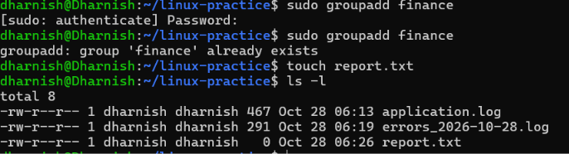
Explanation:
- sudo groupadd finance — Creates a group named finance.
- touch report.txt — Creates an empty file named report.txt.

- Set permissions so the owner can read and write, the finance group can read, and other users have no access. (1 mark)
- Identify the processes consuming the most CPU. (1 mark)
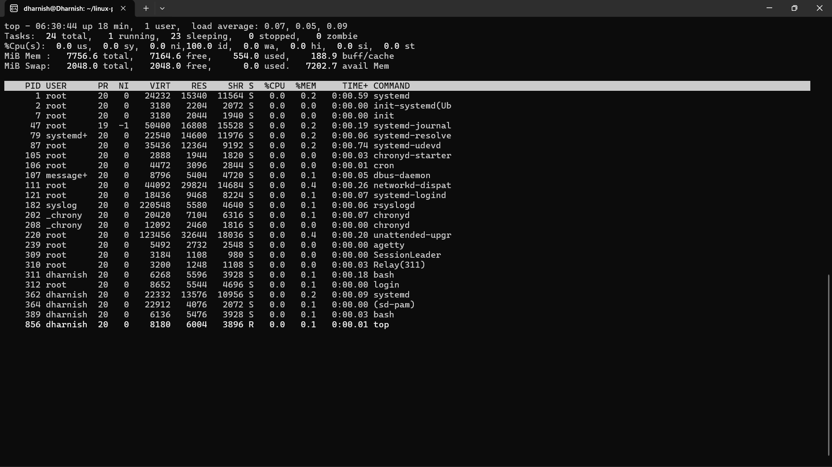
- Display memory usage and filesystem disk utilization. (1 mark)
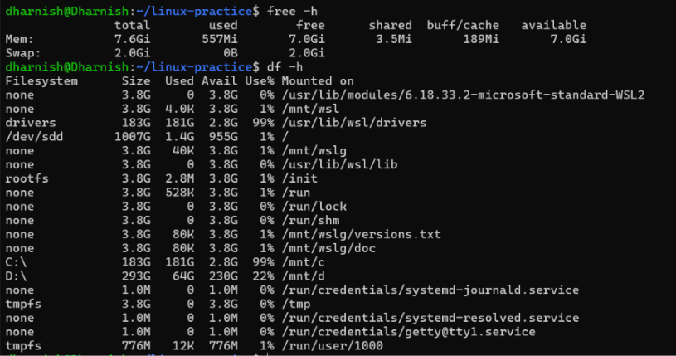
- Find files larger than 100 MB under a specified application directory. (1 mark)
Explanation:
- /path/to/application — Replace this with the actual application directory.
- -type f — Searches for files only.
- -size +100M — Finds files larger than 100 MB.

Question 6: Bash Scripting (5 Marks)
Write a Bash script named backup_check.sh that:
1.Accepts source and destination directories as command-line arguments.
2.Validates that both arguments are provided.
3.Checks whether the source directory exists.
4.Creates the destination directory if it does not exist.
5.Creates a timestamped compressed archive of the source directory.
6.Displays a success message if the backup succeeds.
7.Displays an appropriate error message if the backup fails.
Expected Output: Submit the complete script and demonstrate its execution using valid and invalid arguments.
Evaluation:
- Argument validation and directory checks: 2 marks
- Archive creation: 2 marks
- Error handling: 1 mark
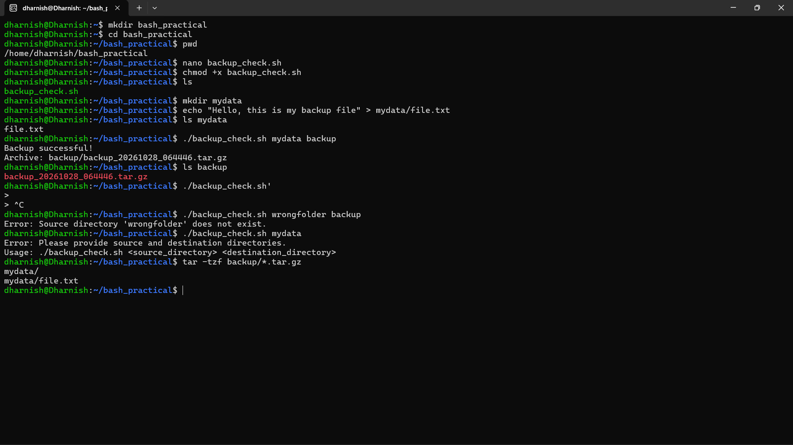

SECTION C: PYSPARK DATA ENGINEERING || Maximum Marks: 20

Question 7: PySpark DataFrame Operations (6 Marks)
- Display the schema and first five records. (1 mark)
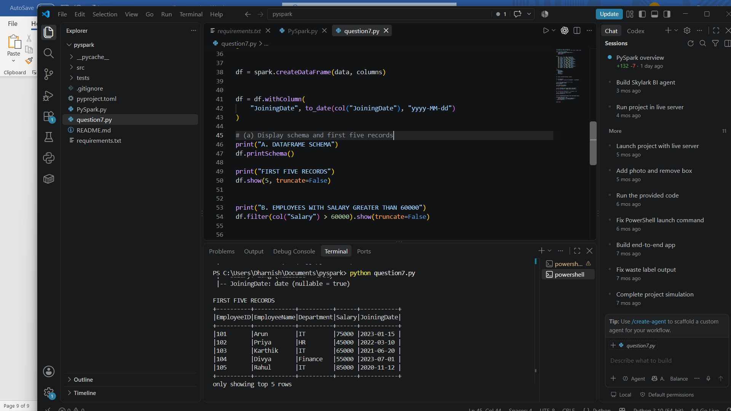
- Filter employees whose monthly salary is greater than ₹60,000. (1 mark)
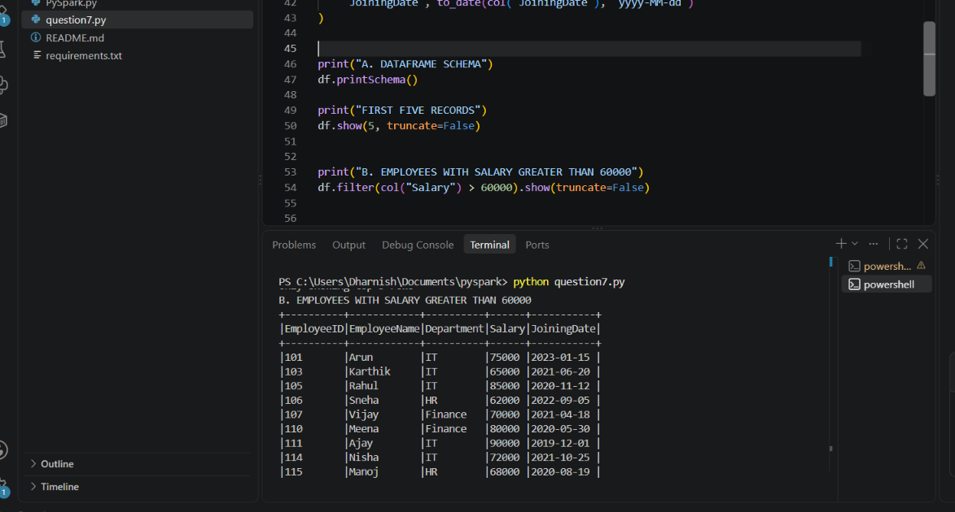
- Add an AnnualSalary column calculated from the monthly salary. (1 mark)
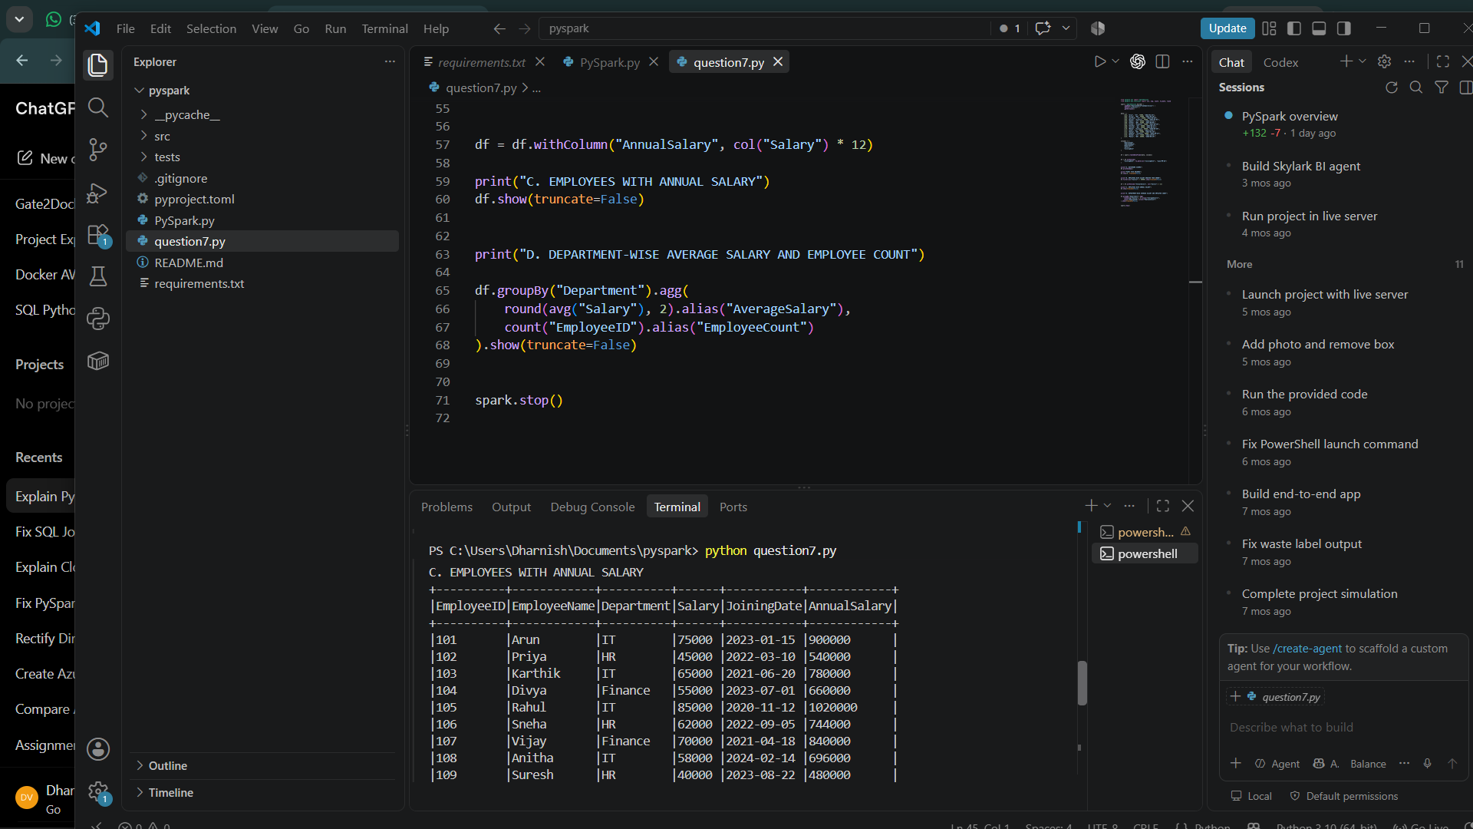

- Group employees by department and calculate the average salary and employee count. (2 marks)
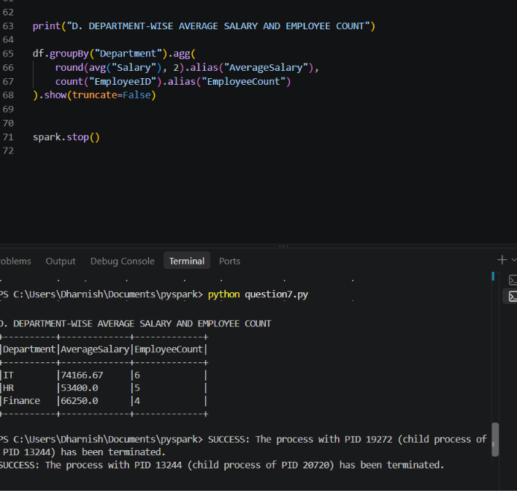
- Display the five highest-paid employees. (1 mark)
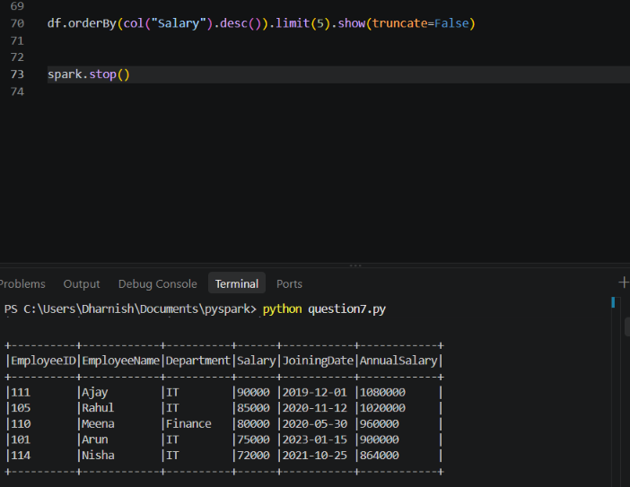

Question 8: Data Cleaning and Aggregation (7 Marks)
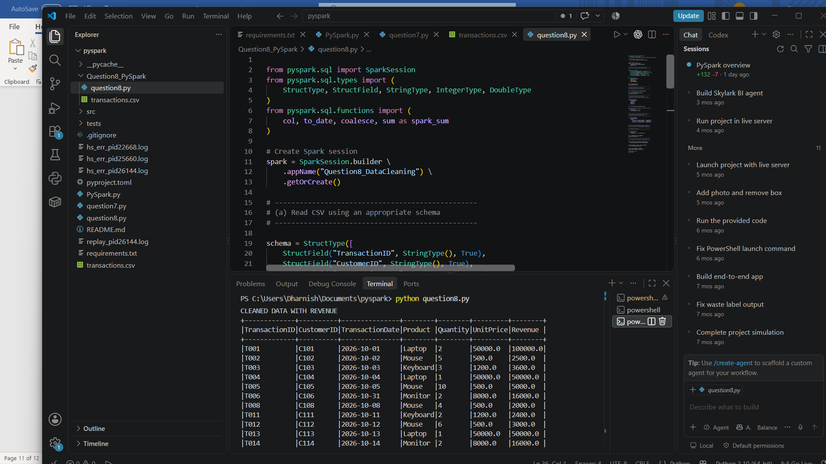
- Read the CSV file using an appropriate schema and header configuration. (1 mark)
df = spark.read.csv(
"transactions.csv",
header=True,
schema=schema
)
- Identify and remove duplicate transactions using a suitable business key. (1 mark)
df = df.dropDuplicates(["TransactionID"])
- Handle missing values in required fields and explain your chosen approach. (2 marks)
df = df.dropna(subset=[
"TransactionID", "CustomerID", "Product",
"Quantity", "UnitPrice"
])

- Convert TransactionDate into a date type and handle invalid dates. (1 mark)
df = df.withColumn(
"TransactionDate",
coalesce(
expr("try_to_timestamp(TransactionDate, 'yyyy-MM-dd')"),
expr("try_to_timestamp(TransactionDate, 'dd/MM/yyyy')"),
expr("try_to_timestamp(TransactionDate, 'dd-MM-yyyy')")
).cast("date")
)
- Calculate revenue using Quantity × UnitPrice. (1 mark)
df = df.withColumn(
"Revenue",
col("Quantity") * col("UnitPrice")
)

- Calculate total revenue by product and display the results in descending order. (1 mark)
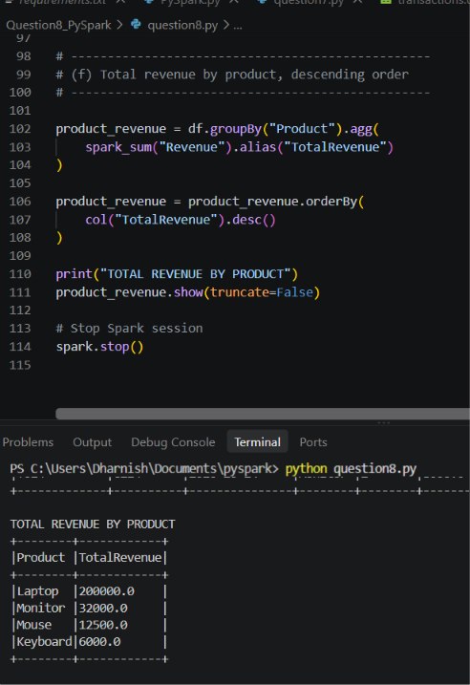

Question 9: PySpark Joins and Performance (7 Marks)
A company maintains two datasets.
Write a PySpark program to:
- Load both datasets into DataFrames. (1 mark)
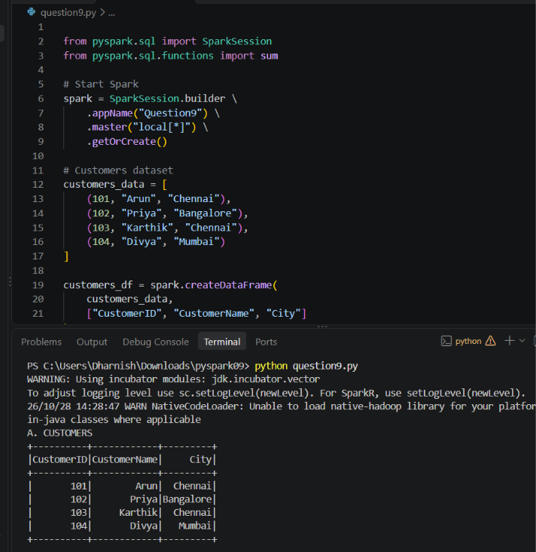

- Join the datasets to display orders with customer details. (2 marks)
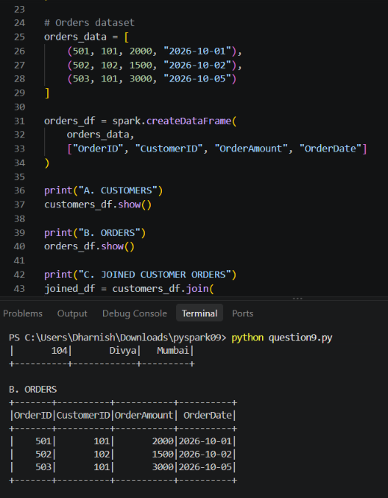
- Identify customers who have never placed an order. (1 mark)
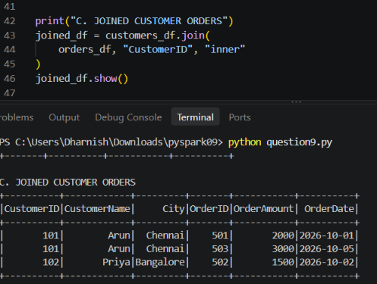
d.Calculate the total order value by city. (1 mark)
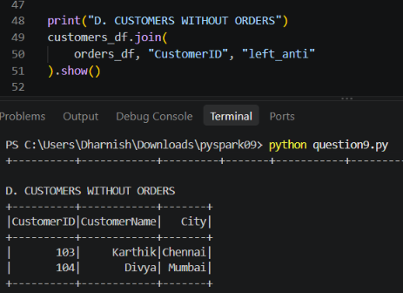

e.Explain when a broadcast join is useful and what conditions make it appropriate.

(1 mark)
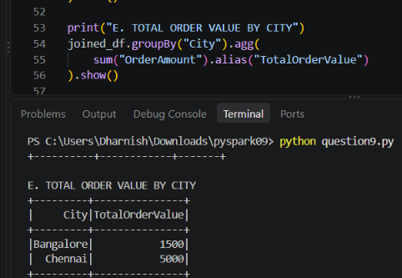
f.Explain the difference between transformations and actions, giving one example of each. (1 mark)
- Transformation: Modifies or creates a DataFrame without executing it immediately. Example: df.filter(df.age > 18)
- Action: Executes the transformations and returns a result. Example: df.show()

SECTION D: AWS CLOUD SERVICES || Maximum Marks: 15

Question 10: S3 and IAM Security (5 Marks)
A company stores confidential employee reports in Amazon S3. Only authorized HR employees should be able to read these reports.
Perform or document the following:
a. Create an S3 bucket with Block Public Access enabled and upload a sample file.

(1 mark)
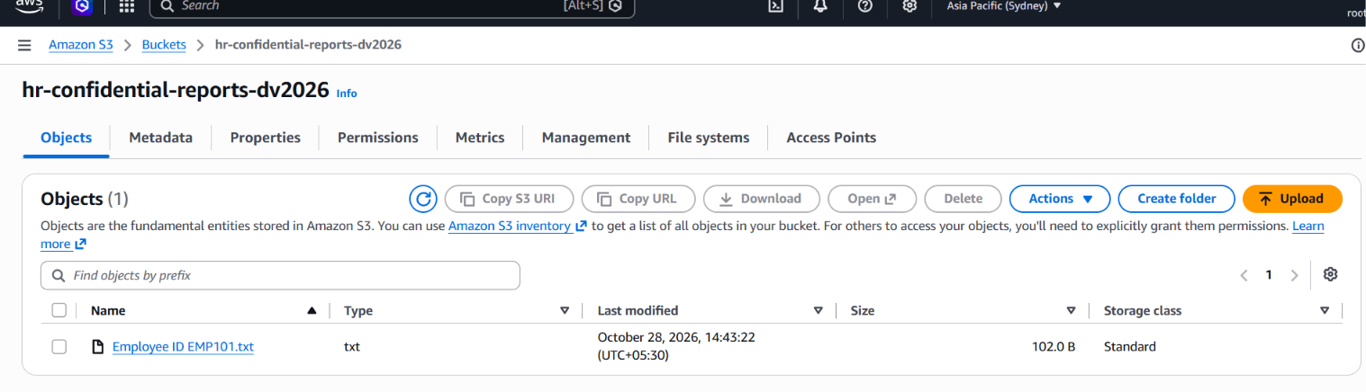

- Design an IAM policy that grants read access to objects in the designated bucket without granting access to unrelated buckets. (2 marks)
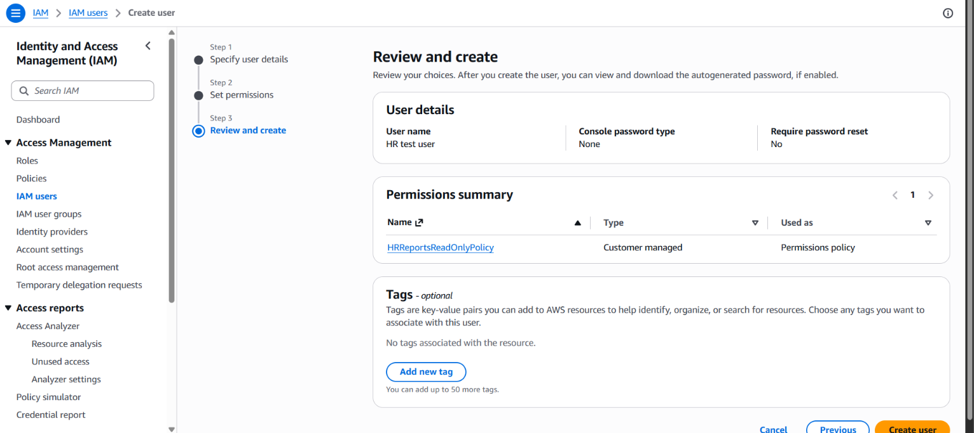
- Explain how you would verify that an unauthorized user cannot read the file. (1 mark)
I will verify access control by signing in as an unauthorized IAM user who does not have permission to read the S3 object. I will attempt to download the employee report. If AWS returns an Access Denied (403) error, it confirms that the unauthorized user cannot read the file.

- Explain how encryption at rest protects the stored data. (1 mark)
Encryption at rest protects stored data by converting it into an unreadable encrypted format. In Amazon S3, Server-Side Encryption with Amazon S3 Managed Keys (SSE-S3) automatically encrypts uploaded files. When an authorized user downloads a file, S3 decrypts it for access. This protects confidential employee reports from unauthorized access to the underlying stored data.

Question 11: EC2 Troubleshooting and CloudWatch (5 Marks)
A web application hosted on EC2 becomes slow, and users report connectivity problems.
Perform or document the following:
- Check the EC2 instance state and status checks. (1 mark)
Question 11: EC2 Troubleshooting and CloudWatch
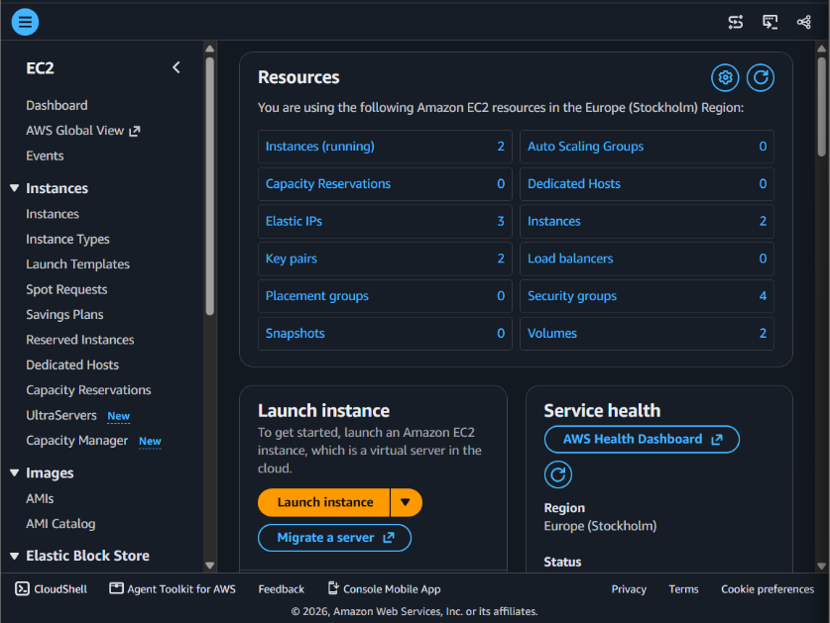

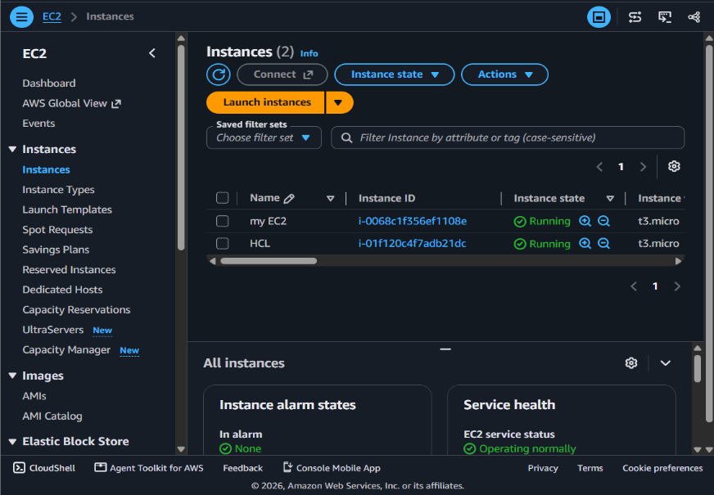

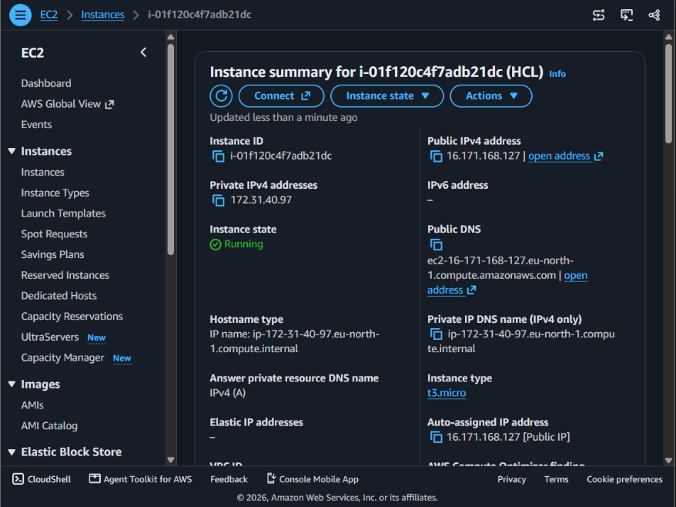

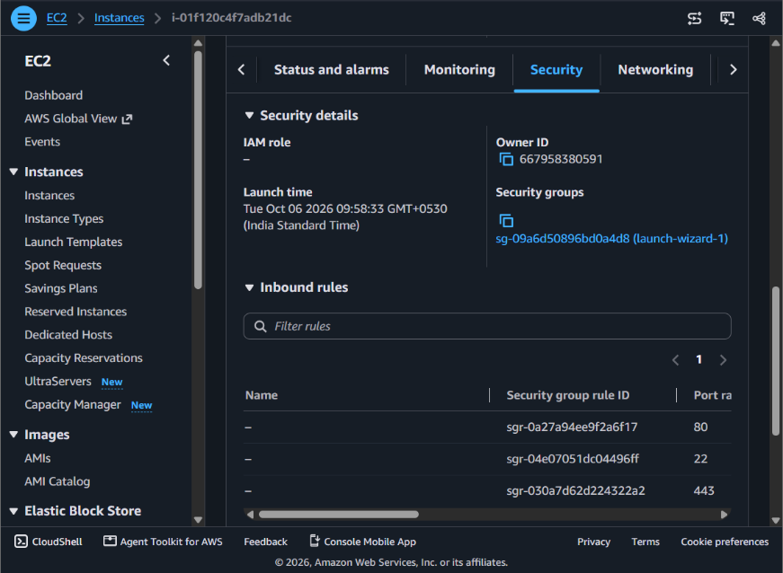

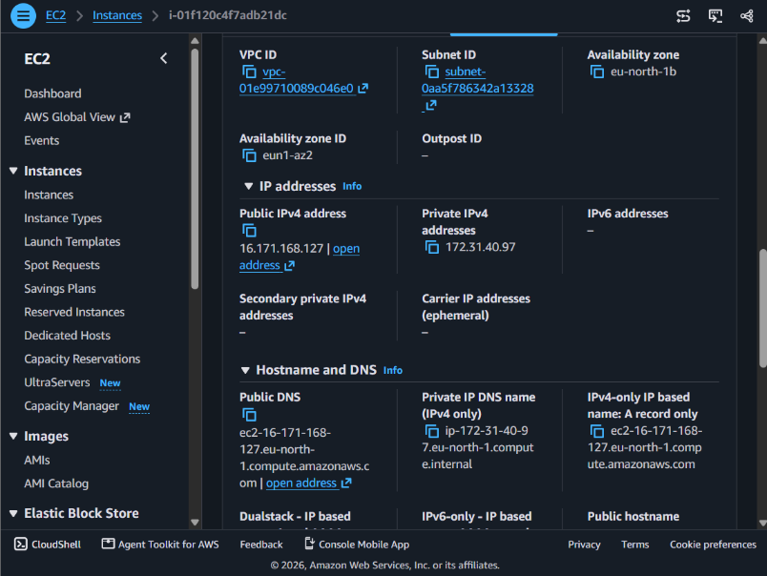

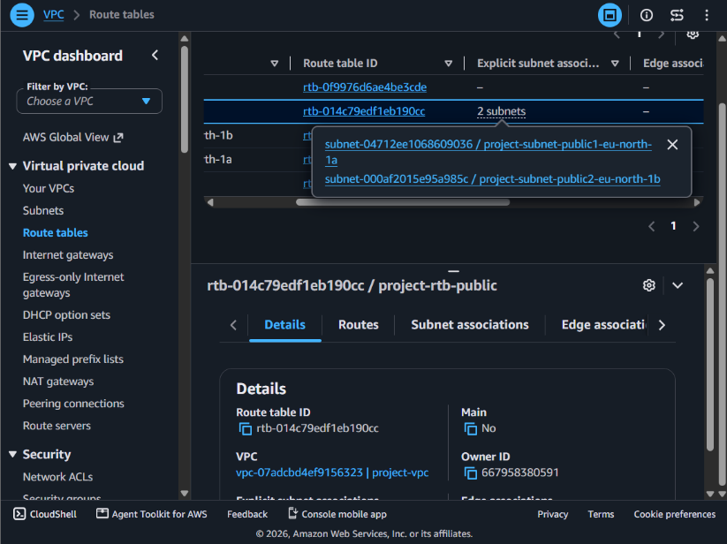

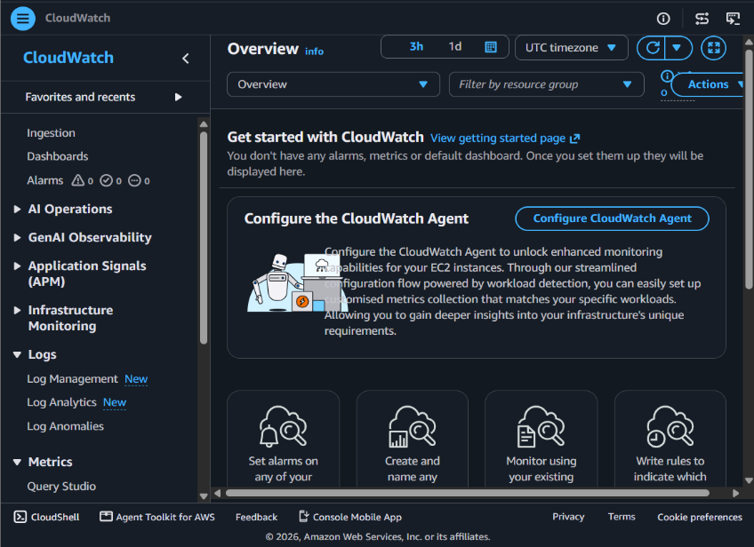

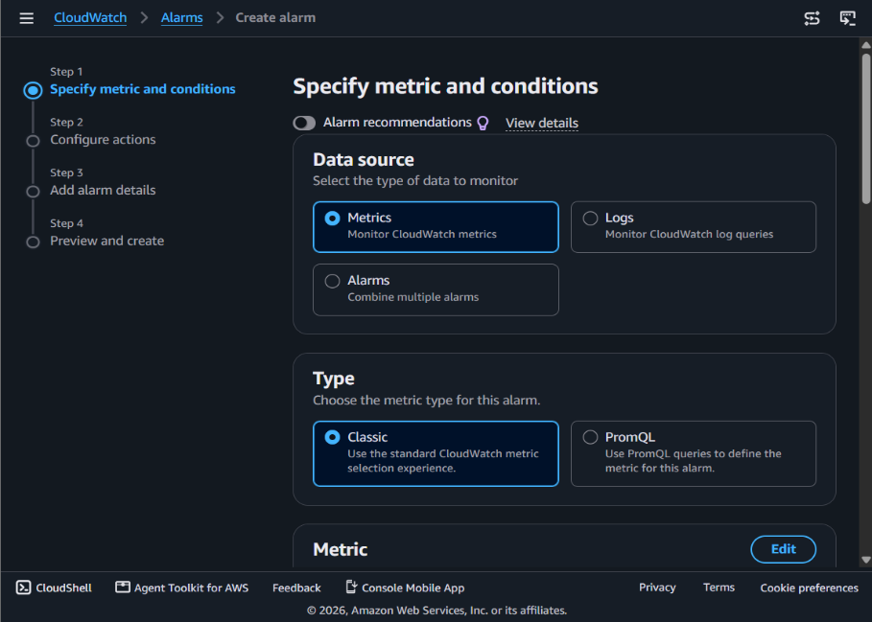

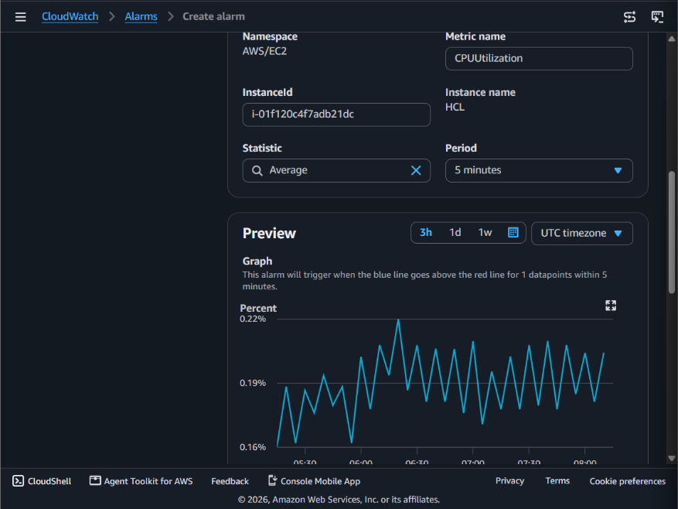

Question 12: Event-Driven Processing
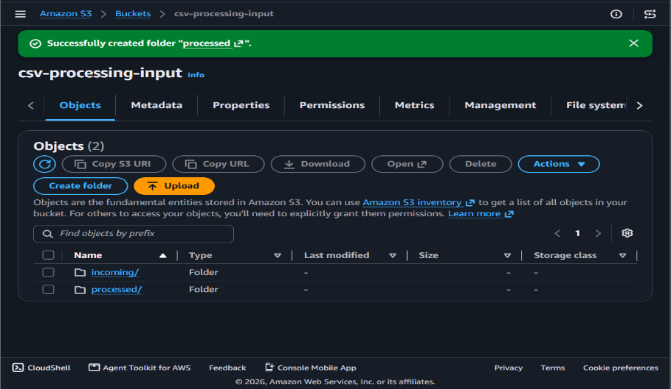

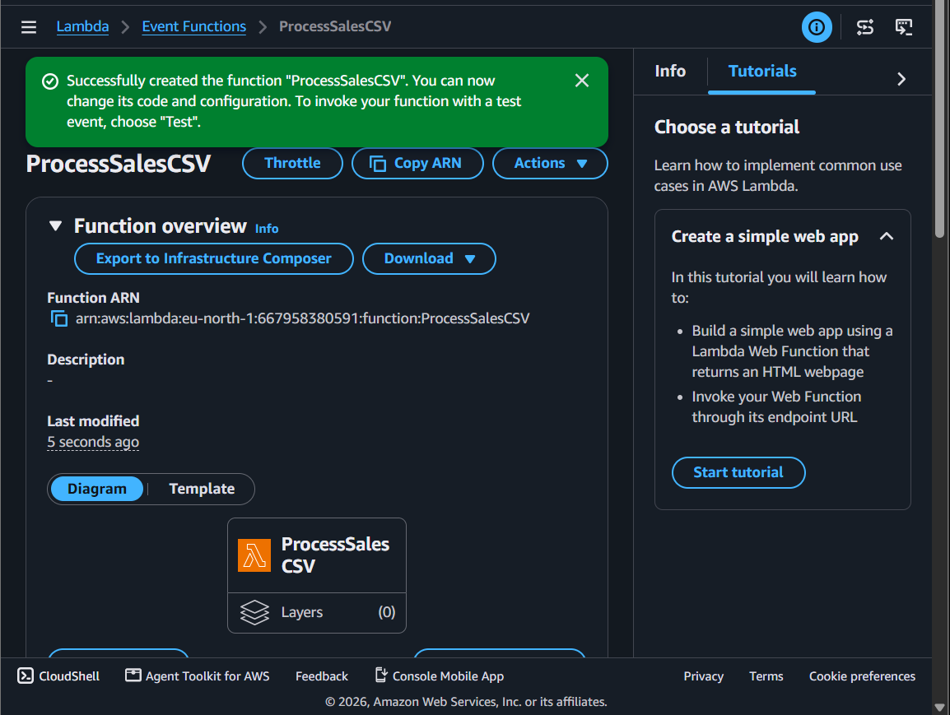

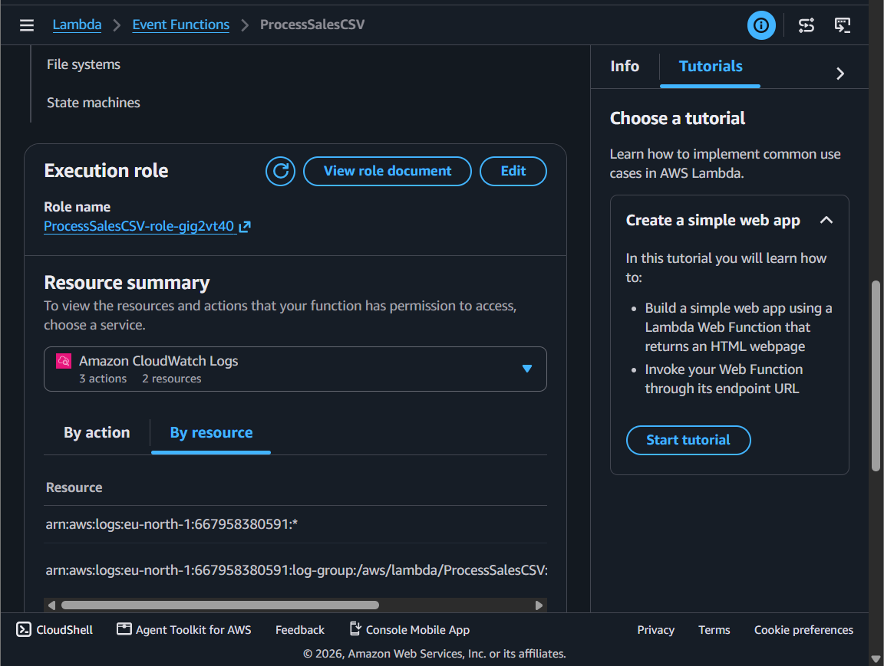

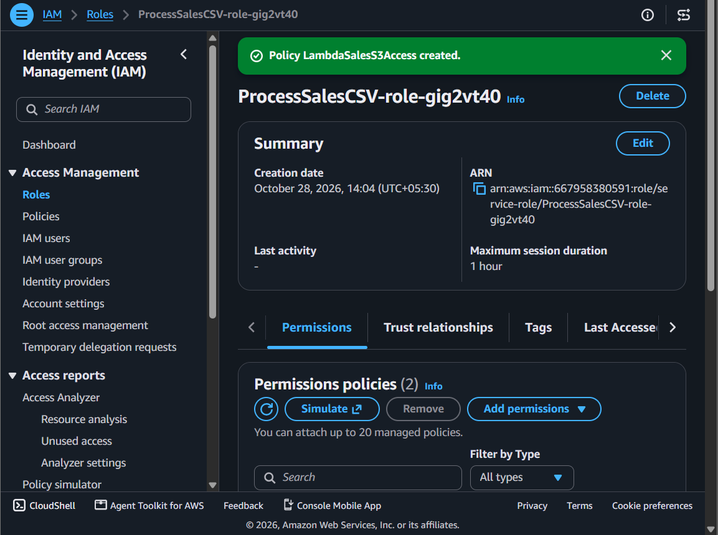

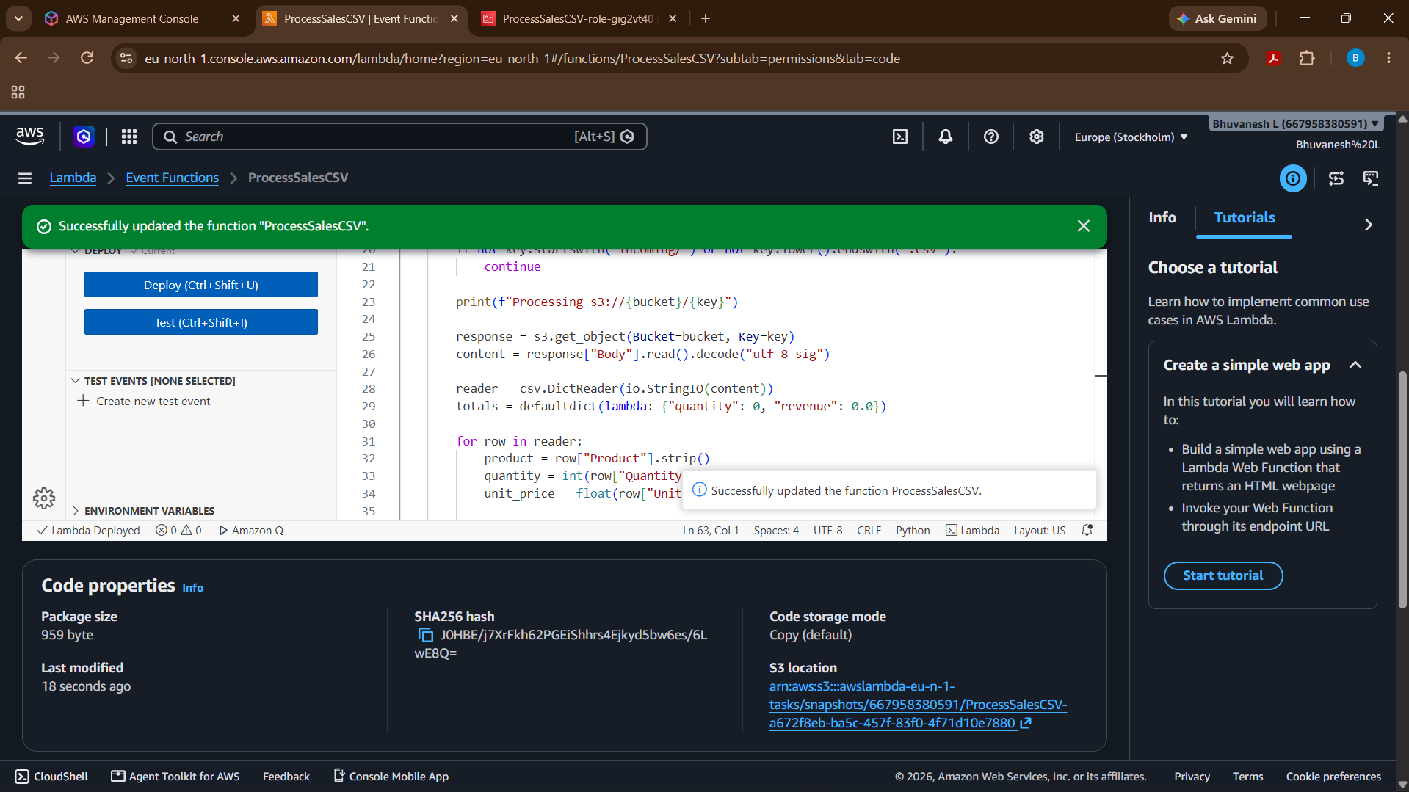

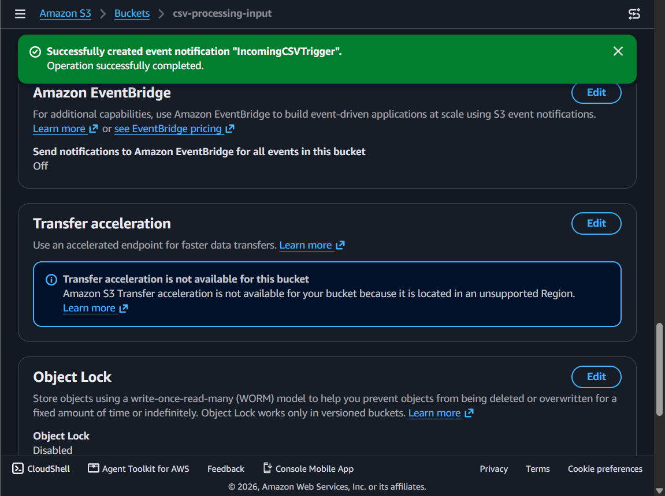

Explain errors and logs
- Amazon CloudWatch Logs records Lambda execution messages, errors, and stack traces.
- Lambda's Monitor tab helps identify invocation failures and execution duration.
- For transient failures, configure appropriate retries and a dead-letter queue or destination where suitable.
- Use the logs to diagnose invalid CSV data, missing permissions, and failed S3 operations.

Prevent duplicate processing and recursive triggers
- Prevent recursive triggering: Configure the S3 notification with prefix incoming/ and suffix .csv. Write outputs to processed/, outside the triggering prefix.
- Prevent duplicate processing: S3 events can be delivered more than once. Make processing idempotent—for example, track processed object keys and version IDs in DynamoDB, or use a durable idempotency key to avoid applying the same transaction twice.
- Handle retries safely: Ensure a retry doesn't create incorrect duplicate business results. Use deterministic output keys and design writes to be repeatable.

SECTION E: AWS STEP FUNCTIONS
Question 13: State Machine Design
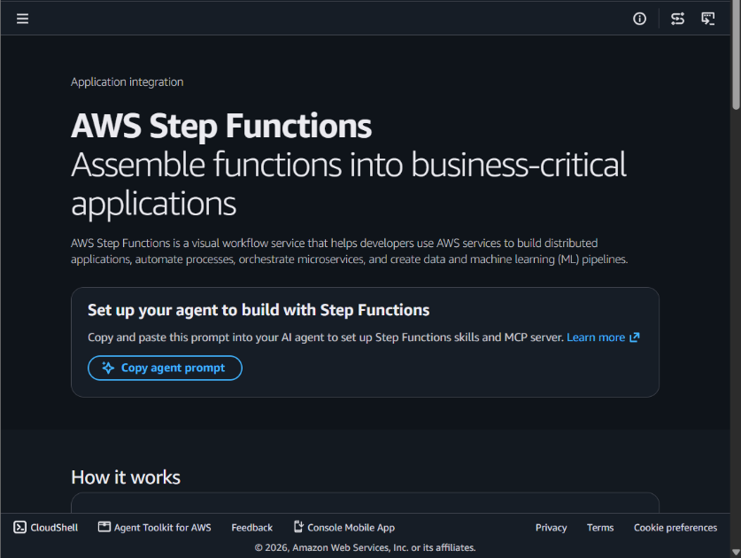

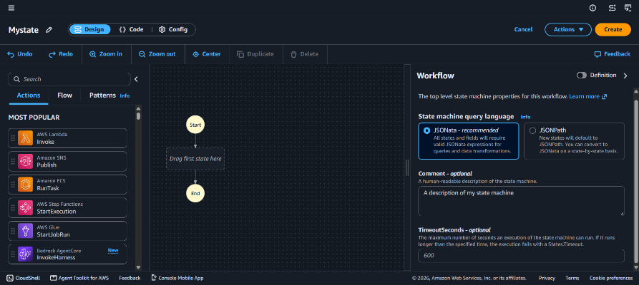

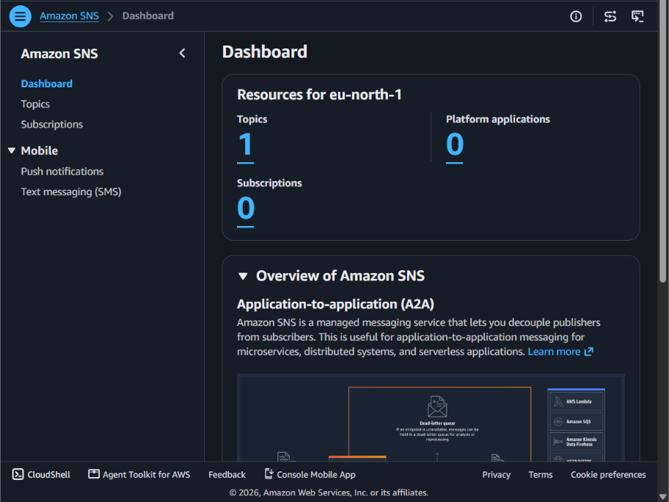

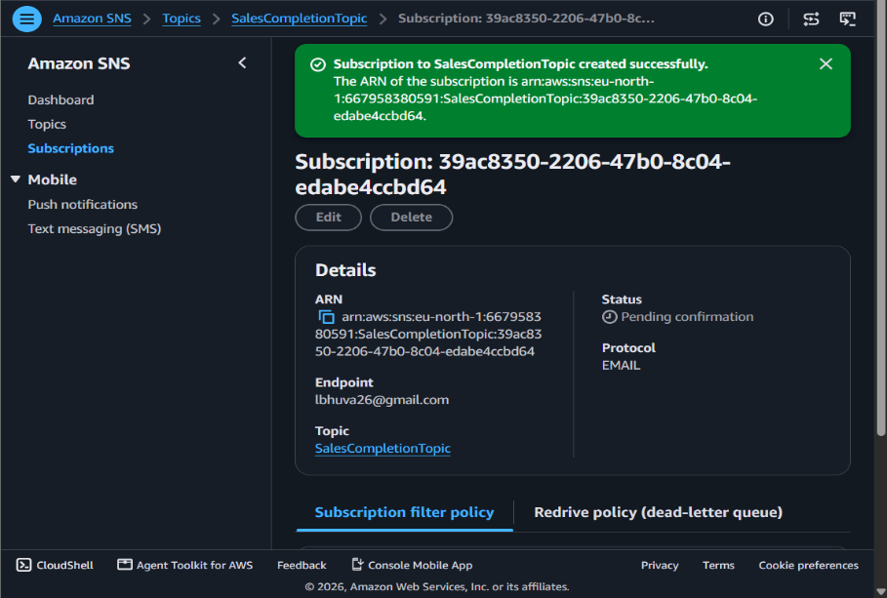

Execute and Verify the State Machine
Open the AWS Step Functions console and select the created state machine. Click Start execution and enter the input JSON containing the S3 bucket name and CSV file path, such as incoming/sales.csv. Replace the sample bucket name with your actual S3 bucket name and click Start execution. Monitor the execution graph to ensure that the ValidateInput, CheckValidation, TransformData, CalculateSales, StoreResults, and SendNotification states complete successfully. Finally, open the S3 bucket's processed/ folder and verify that sales_summary.csv has been created. Check your email for the SNS completion notification to confirm that the workflow has finished successfully.

Question 14: Step Functions Implementation

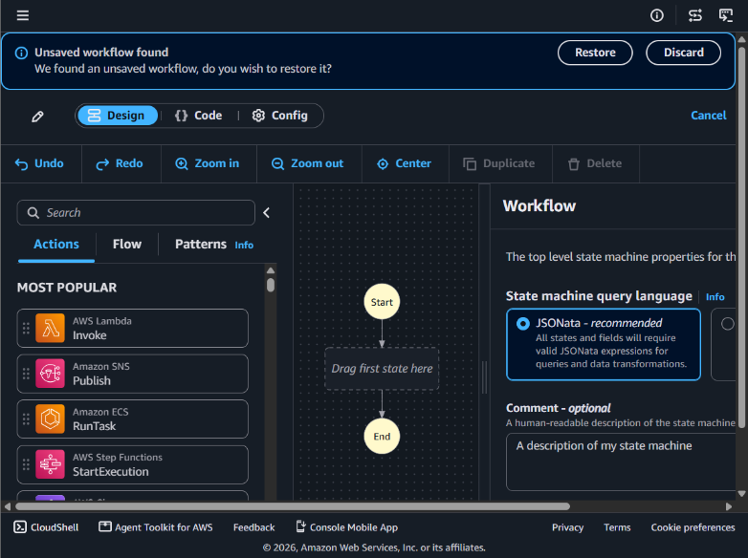

Explain how data from one task is passed to the next task.
In AWS Step Functions, data is passed between tasks as JSON input and output. The output of one task becomes the input of the next task. The ResultPath field stores a task's result in the execution data, while Payload.$ passes the current JSON data to a Lambda function. This allows each task to use the results produced by previous tasks during workflow execution.

e. Explain how you would test successful and failed executions.
To test successful execution, start the state machine with valid input data and verify that ValidateFile, TransformData, and LoadResults execute in sequence and finish successfully. To test failed execution, provide invalid input to make validation fail, simulate a temporary transformation error to verify retries, and simulate a loading error to verify that the Catch transition records the failure. Check the AWS Step Functions execution history to inspect state transitions, retry attempts, and error details.

SECTION F: MICROSOFT AZURE
Question 15: Azure Data Lake Storage and Security
Step 1: Open Azure Portal
Open the Microsoft Azure Portal and sign in using your Azure account. Search for Storage accounts in the top search bar and select the service to begin creating a storage account.

Step 2: Create a Storage Account
Click Create and select your subscription and resource group. Enter a globally unique storage account name, choose a region, select Standard performance, and configure the required redundancy option.

Step 3: Enable Hierarchical Namespace
In the Advanced tab, find the Hierarchical namespace option and enable it. This feature enables Azure Data Lake Storage Gen2 capabilities, including directory-based organization and file-system semantics. Click Review + create, validate the configuration, and click Create.

Step 4: Create a Container
After deployment, open the storage account and navigate to Data storage → Containers. Click + Container, enter the name salesdata, and set the anonymous access level to Private (no anonymous access). Click Create to create the container securely.

Step 5: Create a Sample Dataset
Open Notepad on your computer and enter sample employee data with columns such as EmployeeID, EmployeeName, Department, and Salary. Save the file as employees.csv, selecting All files in the Save As dialog if necessary.

Step 6: Upload the Dataset
Open the salesdata container in Azure Portal and click Upload. Browse your computer, select employees.csv, and click Upload. Verify that the uploaded file appears in the container.

Step 7: Configure Access Using Microsoft Entra ID and Azure RBAC
Open the storage account and select Access control (IAM). Click Add → Add role assignment, select the Storage Blob Data Reader role, and choose the authorized user or group from Microsoft Entra ID. Click Review + assign to apply the permissions.

Step 8: Verify Authorized Access
Sign in as the authorized user or use an authenticated storage client. Open the salesdata container and attempt to read or download employees.csv. Confirm that the user can access the dataset with the assigned read-only permissions.

Step 9: Verify Unauthorized Access
Use a separate test identity that has no applicable data-access permissions. Attempt to access the same dataset and confirm that Azure denies access. Keep the container private and check for any inherited roles or other permissions that might grant access.

Question 16: Azure VM Troubleshooting
Step 1: Verify VM Provisioning and Power State
Open the Azure Portal and navigate to Virtual Machines. Select the required VM and check its provisioning status and power state. Ensure that the VM is successfully provisioned and running.

Step 2: Check Network Security Group (NSG) Rules
Open the VM's Networking settings and review the associated NSG rules. Check whether the required inbound and outbound ports are allowed. Incorrect rules may block connectivity to the VM.

Step 3: Verify Subnet and Routing Configuration
Check the virtual network and subnet assigned to the VM. Review the route table and verify that traffic is directed to the correct destination. Incorrect subnet or routing configurations can prevent network communication.

Step 4: Use Azure Network Troubleshooting Tools
Use Azure Network Watcher to diagnose connectivity issues and inspect effective security rules. Identify blocked traffic and correct the relevant network configuration. Test the connection again after making changes.

Step 5: Follow Secure Troubleshooting Practices
Avoid exposing VM management ports directly to the public internet. Use Azure Bastion for secure SSH or RDP access and restrict network access to trusted sources. Apply the principle of least privilege.
Question 17: Azure Data Integration

Step 1: Create Azure Data Factory
Open the Azure Portal and search for Data Factory. Create a Data Factory instance by selecting the subscription, resource group, region, and name. Open Azure Data Factory Studio to create and manage pipelines.

Step 2: Connect CSV Files to ADLS Gen2
Create a linked service to connect Azure Data Factory to Azure Data Lake Storage Gen2. Configure the source dataset to read daily customer transaction CSV files. Set the destination dataset to the required storage container.

Step 3: Organize Data into Date-Based Folders
Configure the pipeline to store files in date-based folders, such as year=2026/month=10/day=28. This structure helps organize daily transaction data. It also makes searching and processing data for specific dates easier.

Step 4: Handle Malformed and Missing Records
Validate CSV records for missing values, incorrect data types, invalid dates, and missing required fields. Separate invalid records from valid records during processing. Store rejected records in a separate quarantine folder for further investigation.

Step 5: Monitor Pipeline Execution
Open the Monitor section in Azure Data Factory Studio to check pipeline status. Review failed activities, error messages, and execution details. Configure alerts for failures so that issues can be identified and resolved quickly.

Step 6: Validate the Output Data
Check the processed files in ADLS Gen2 to confirm that records are stored correctly. Compare the source, successfully processed, and rejected record counts. Verify that valid data is stored in the correct folders and invalid records are separated.

